**3. Deploy NLB Basics k8s manifests, Verify and CleanUp**

--- Reference - <https://github.com/stacksimplify/aws-eks-kubernetes-masterclass/tree/master/19-ELB-Network-LoadBalancers-with-LBC>

**Deploy all kube-manifests**

--- **note** – here, I will deploy kubernetes manifests and verify for network load balancer.

**# list the manifests**

--- **ls -lrta kube-manifests**

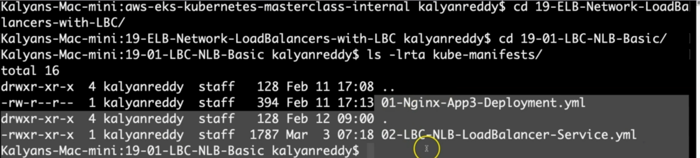

**# Deploy kube-manifests**

--- **kubectl apply -f kube-manifests/**

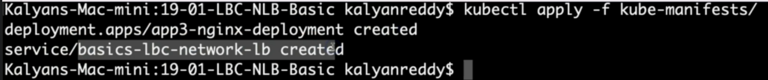

**# Verify Pods**

--- **kubectl get pods**

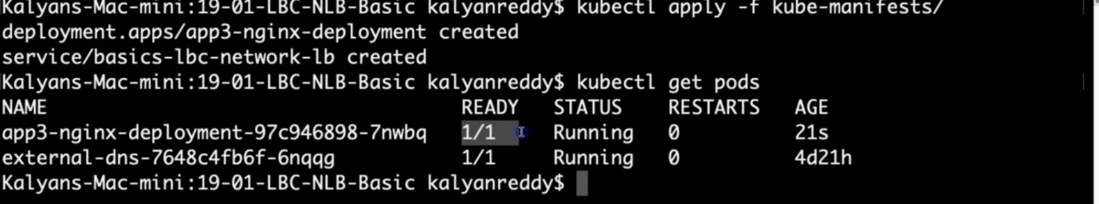

**# Verify Services**

--- **kubectl get svc**

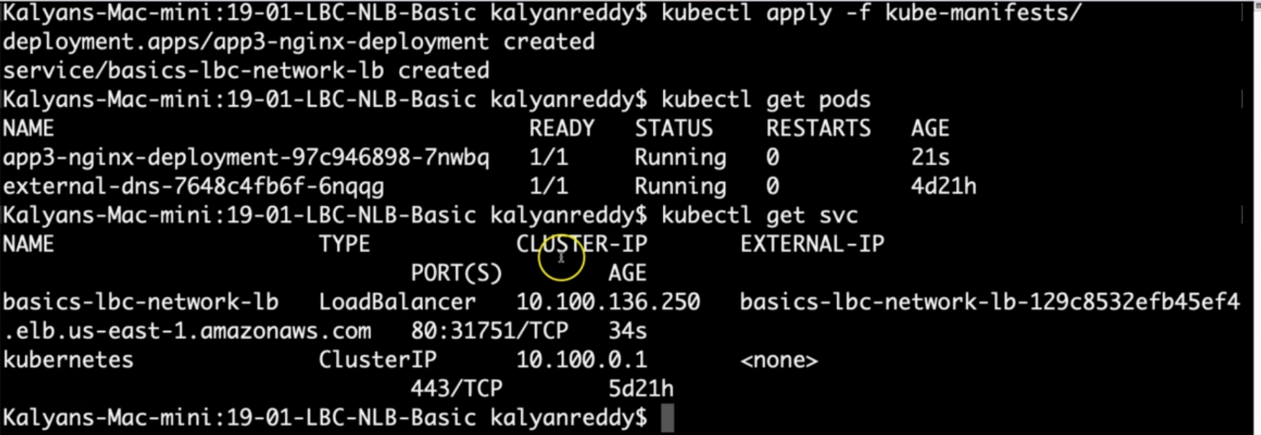

**Observation:**

1. Verify the network lb DNS name

--- **note** – the external ip is nothing but dns name of load balancer.

**# Verify AWS Load Balancer Controller pod logs**

--- kubectl -n kube-system get pods

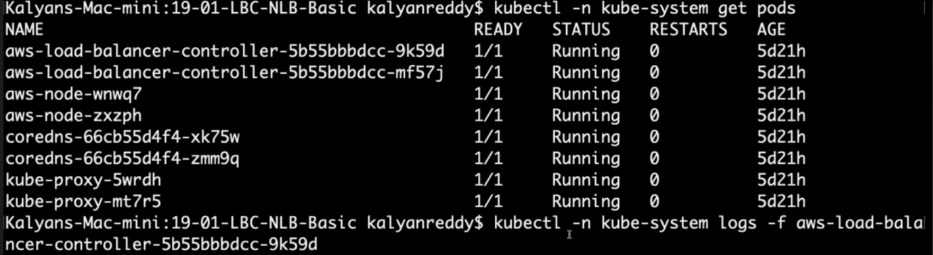

--- kubectl -n kube-system logs -f <aws-load-balancer-controller-POD-NAME>

**# Verify using AWS Mgmt Console**

Go to Services -> EC2 -> Load Balancing -> Load Balancers

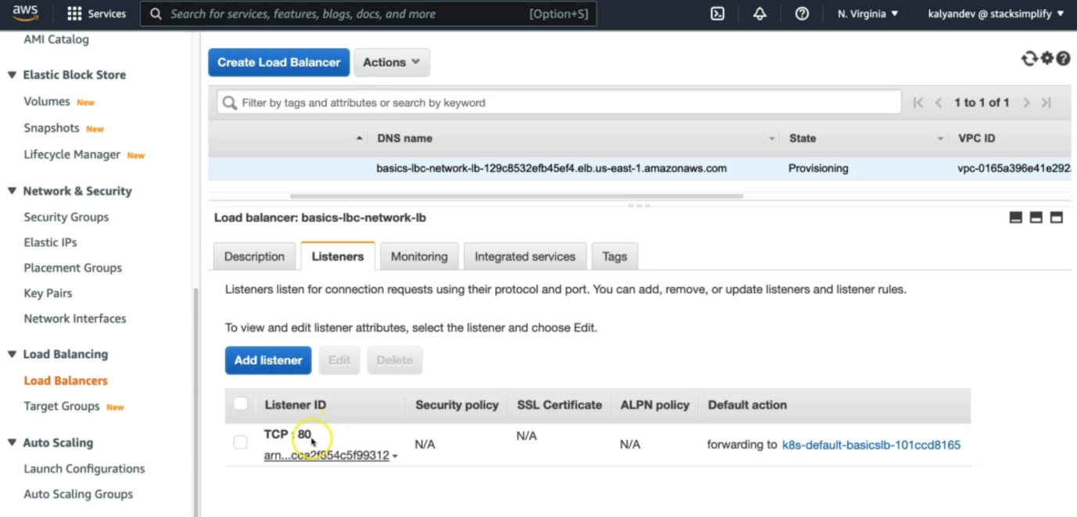

--- **note** – you can directly click on the forward to

1. Verify Description Tab - DNS Name matching output of "kubectl get svc" External IP

2. Verify Listeners Tab.

Go to Services -> EC2 -> Load Balancing -> Target Groups

1. Verify Registered targets

2. Verify Health Check path

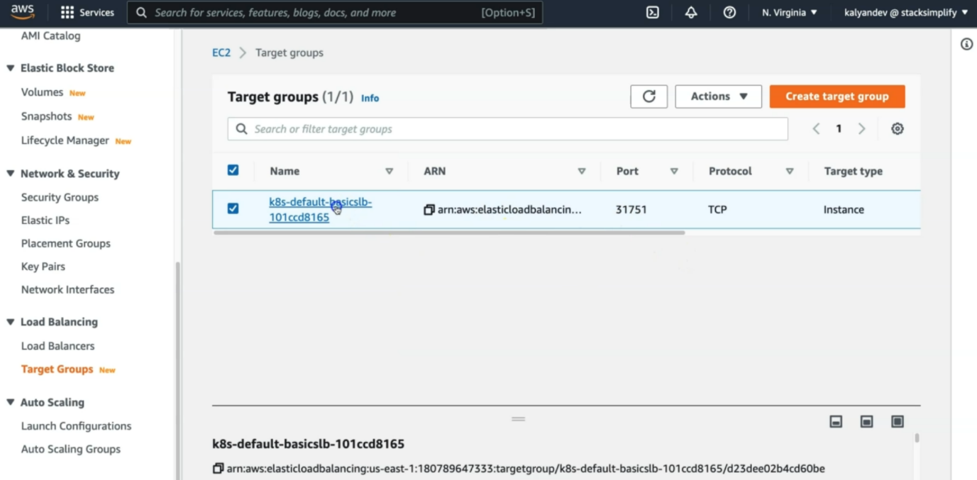

--- **note** – target group port number should match with service port.

--- **kubectl get svc**



--- click on the target group.

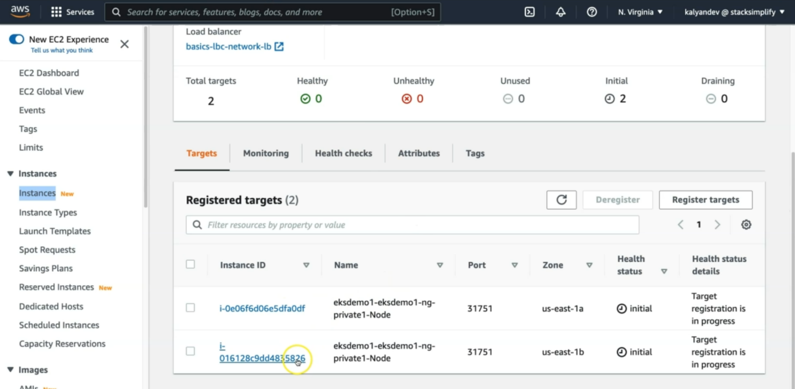

**# Access Application**

--- http://<NLB-DNS-NAME>

**Clean-Up**

**# Delete or Undeploy kube-manifests**

--- kubectl delete -f kube-manifests/

**# Verify if NLB deleted**

In AWS Mgmt Console,

Go to Services -> EC2 -> Load Balancing -> Load Balancers

**References**

--- Network Load Balancer - <https://docs.aws.amazon.com/eks/latest/userguide/network-load-balancing.html>

--- NLB Service - <https://kubernetes-sigs.github.io/aws-load-balancer-controller/v2.4/guide/service/nlb/>

--- NLB Service Annotations - <https://kubernetes-sigs.github.io/aws-load-balancer-controller/v2.4/guide/service/annotations/>